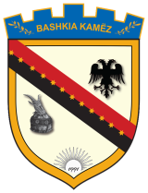
Kamza Municipality profile for EU Project Partnership
Geographical area
Kamza is located 7 km far from the capital city, Tirana and it is the 6th largest city in Albania. It is bordered on the north by Kruja, on the south by Tirana, on the east by Zall-Herri and on the west by Bërxulla. The geographical position of Kamza is particularly interesting from the point of view of the environment, cultural heritage and landscape of the region. Kamza is surrounded by two rivers to the north and south. Kamza occupies a position of great interest also in relation to the national system of protected areas. Geographically, Kamza is a central point of multimodal transport networks. It is located at the crossroads of Rinas International Airport, the national highway (SH1) that connects Tirana to the east and the northern cities of Lezha, Shkodra, as well as Kosovo and Montenegro. The geographical position of this city is most advantageous in the triangle strategic, Tirana - International Airport "Mother Teresa - The largest port of Albania, Naval Port of Durres, which offers great opportunities for development and change.

Administrative structure of Kamza Municipality

The Municipality of Kamza, after the new territorial division includes under its administration the administrative unit Paskuqan. Kamza, as a local administrative unit of the first instance, is administratively divided into:
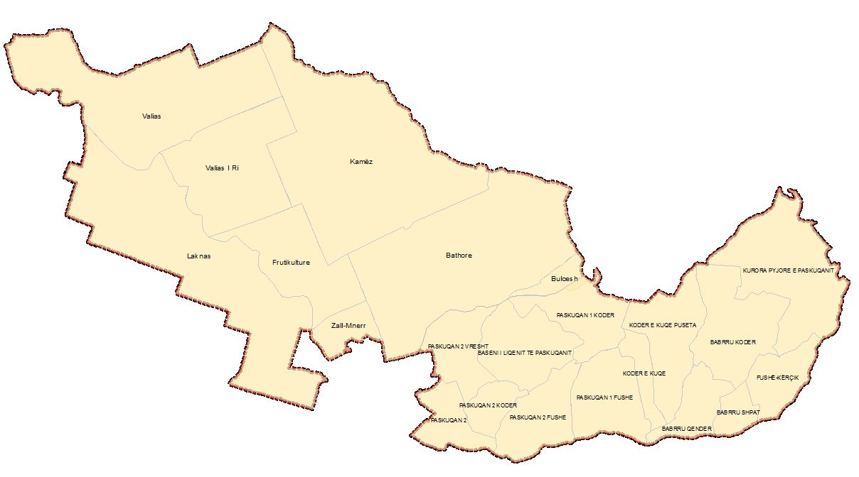
- Urban center (city center)

Kamza as an urban center is divided into its respective villages: 1-Bathore, 2-Laknas, 3-Valias, 4-Valias i Ri, 5-Frutikulturë, 6- Bulçesh, 7- Zall-Mner.

- Administrative unit Paskuqan
It is divided into the following villages: -Paskuqan 1, -Paskuqan 2, -Babrru Qëndër, -Kodër e Kuqe, -Babrru-Shpat, -Fushë e Kërçikëve, -Babrru Kodër, -Paskuqan 1 Fushë, -Paskuqan 1 Kodër, -Paskuqan 2 Fushë, -Paskuqan 2 Kodër.
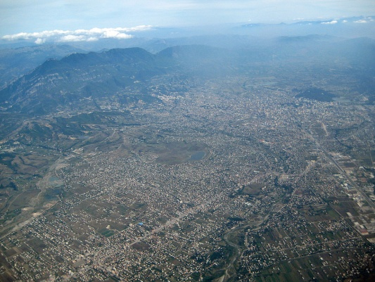
General Data and contacts:
- Country Albania
- Population 138.454 inhabitance
- Area (Kamëz dhe Paskuqan) 37.18 km2
- E-mail bashkiakamez@gmail.com
- Tel +355 47 200 177
Vision
The vision for the future of Kamza and Paskuqan is the involvement of young people in decision-making processes and the design of well-defined policies for the management of the institution, as well as for the development of the city. Part of this vision is to build an efficient structure of the Municipality, focusing on nurseries, kindergartens and schools. Another priority is the realization of waterworks, where 58% of the territory is uncovered, also focus on sewerage.
Mission
Provision of quality services, support of the highest level of provision in the management of sustainable development, equal opportunities for the well-being of citizens oriented towards a sustainable economy, promoting and protecting our established heritage, cultural assets and a unique inter-community integration, supporting and empowering young people, as well as increasing the role of the citizen in society, are the best guarantee for a future of peace, stability, prosperity and freedom.
Challenges
Within the framework of new territorial reform, the Municipality of Kamza has identifies the following priority areas:
- Socio-economic development,
- Urban development and transport,
- Tourism development,
- Public services,
- Waterworks and sewerage system,
- Environmental protection,
- International relations and partnerships.

- Socio-economic development
Laying the foundations for economic and social development is a fundamental priority for the Municipality of Kamza. With the establishment of sound commercial and administrative infrastructures, the development of business, the strengthening of democracy will ensure sustainable developments in terms of living standards of citizens. The main goal is to initiate economic development through public spending, regulation and promotion of various pro-business initiatives. As well as creating a more supportive and competitive business environment through leadership and policy making.
- Urban development and transport
In the Municipality of Kamza has been a boom of investments everywhere in infrastructure, schools, kindergartens, parks, sports fields as well as in socio-cultural facilities. Extensive investments in time and space will have a fundamental change in the appearance of the city with a profound environmental impact and improved infrastructure. The management of the road network and public transport in the city of Kamza has aimed at an integrated approach to economic development, improving the lives of citizens and protecting the environment. The goal of the Municipality of Kamza remains the development of a road network and a frequent, fast, reliable and comfortable public transport.

- Tourism development
Under the model of Urban Renaissance, in the program focused on tourism and agribusiness, will take place the complete infrastructural, cultural and historical rehabilitation of the village of Laknas. Laknas is an agricultural area, with an early tradition in Albania as the former vegetable production village for all of Albania. A characteristic of the village that stands out as it passes through its streets, are the vegetable greenhouses. This village offers opportunities for cycling, horseback riding, hiking. UKA Farm and Blerina Farm are two destinations to visit. The UKA Farm restaurant is located in the middle of the farm in the fresh air, giving you the opportunity to enjoy local food and wine. Blerina Farm offers the food it produces on its farm, foods with nutritional value because it grows naturally and is offered freshly harvested.
- Public services
The Municipality of Kamza is committed to provide as much quantitative and qualitative services as possible to the citizens of the community of Kamza. Many operations and services have been undertaken that directly affect the improvement of infrastructure and services for citizens. The services offered are: -Cleaning of the entire territory of the Municipality of Kamza, -Maintenance of all roads and sidewalks, also their lighting, -Transport of all urban waste to landfill, -Maintenance of waste collection point and good functioning, Greening of public spaces of the city,-Planting with decorative trees of new streets

- Waterworks and sewerage system
Waterworks and sewerage system Kamëz sh.a combines entrepreneurial activity and social responsibility, to provide safe drinking water supply services with acceptable tariffs and protection of water resources. Mission of the Waterworks and sewerage system:
- To provide drinking water supply 24 hours a day, quality clean water, continuously, uninterrupted and with the right pressure.
- To guarantee a safe wastewater disposal and treatment system to protect public health, in accordance with national standards for the protection of health and the environment.
- To provide a suitable communication environment, to promote cooperation and increase the capacity of the company's staff.
- To continuously improve the financial performance in order, with the most affordable tariffs for the public and businesses, to enable the coverage of all costs, including not only the maintenance of assets but also new investments.

- Environmental protection
The Municipality of Kamza has had a total transformation of the way of organization, from the agricultural economy to an urban center, with an increased need for the large number of population per km². The natural potential or natural resources are at a satisfactory level, harmonized with each other and that enable their rational use, preservation, conservation to serve future generations. In the territory of the Municipality of Kamza there are water sources that cross the country, there are groundwater reserves, there is a considerable area with forest area or the former Green Crown of Paskuqan, with a good biodiversity of characteristic species of the area, but and with the interventions made there is an increase of the urban green area, through the planting of ornamental trees. With the work done, there is a good environmental situation by improving important environmental indicators such as parameters of air quality, water, solid waste, hospital waste, increase of urban green spaces, asphalting of the road network, etc. Projects launched in infrastructure, in the KUZ network, waste management, construction of plants, as well as the addition of urban green areas would lead to a new standard of local environmental parameters and beyond.
- International relations and partnerships
Since 2013 the institution has made a progress in Europe for Citizens Programme as a partner in the JOGGLE (JOin Generations for Getting Legality in Europe) project which was a bottom-up project on the illegalities which had the focus on citizens' daily lives. The participants exchanged their experiences on legislative processes at the local and European level. JOGGLE contributed on the objectives of 2013 EU Year of Citizens, 2012 EU Year of intergenerational Solidarity, 2011 EU Year of Voluntary, 2014 EU Year against food waste. The project included 3 European Conferences (2 were held in Italy and 1 in Kamez) with the aim of promoting Legality: meanings, assumptions, aspects and weaknesses; European Intergenerational Solidarity; Fight to the food waste; Rights and Legality: case-studies and good practices. The Municipality of Kamez wants to promote a European town twinning, type: Thematic Network of Towns, on the theme of Be EU Citizen: Building Europe through CIVIC participation.

